110年計算機結構 第6次小考
  - (20%) Design the system architecture of matrix multiplier based the following figure.
  - (30%) Give the inputs (X and Y) of your system architecture at minimum latency.
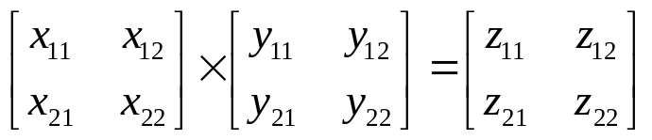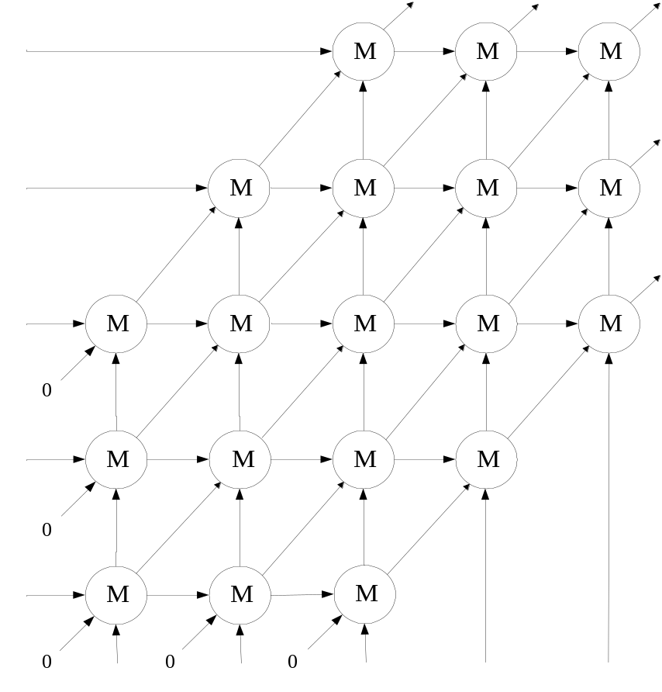

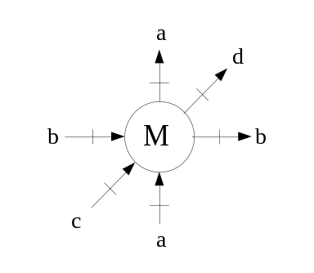
d = a x b + c

- (50%) Figure 1 is the cell of matrix multiplier.
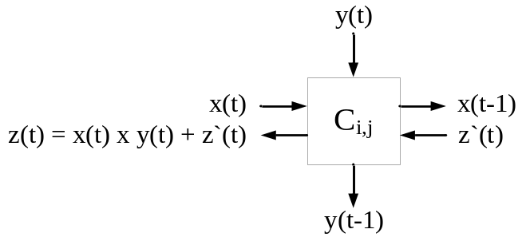
Figure 2

2.1 (10%) Give the architecture of matrix multiplier by the cells.
2.2 (20%) Give the inputs of your architecture.
2.3 (10%) Find the minimum output time of Z11and Z22.

